IRIS DATASET_PYTHON PROJECT QUESTIONS
#QUESTION NO:1
Load and Inspect the Data:
1.How many rows and columns does the dataset have?
2.Which variables are numerical and categorical?
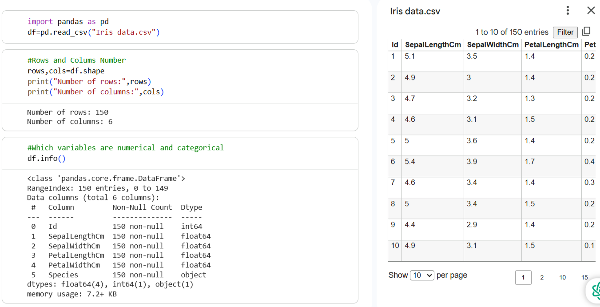
#QUESTION NO:2
CHECK DATA QUALITY:
Missing values:
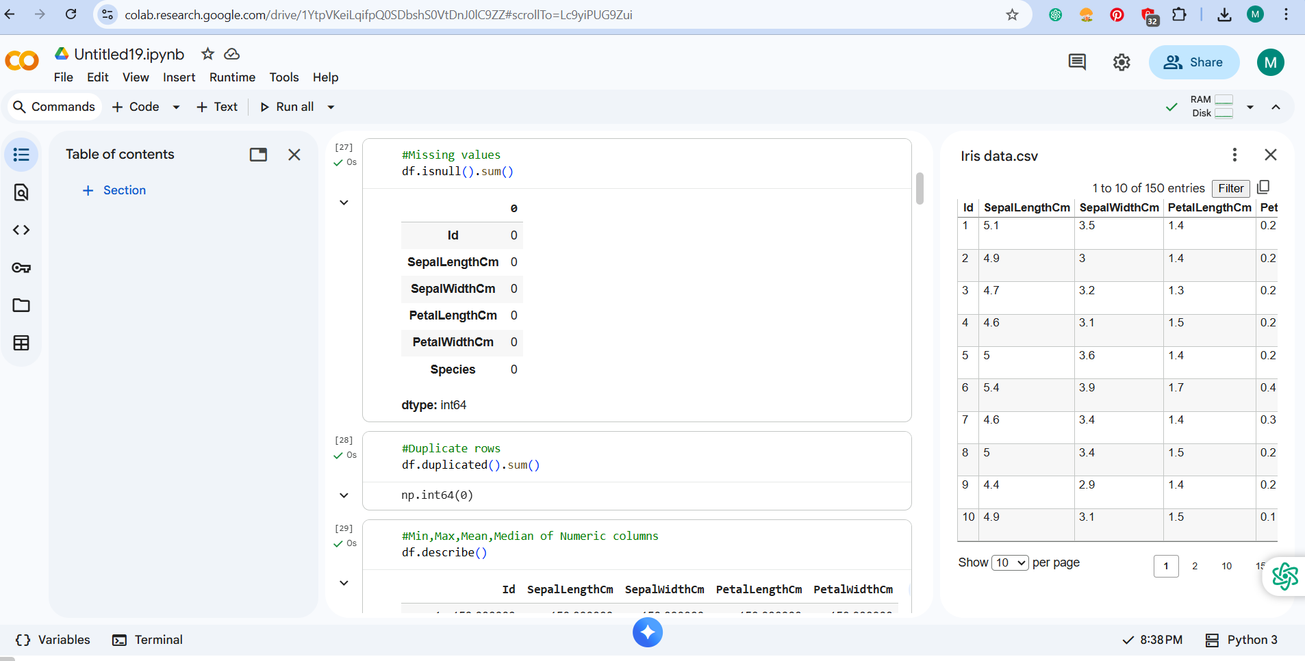
Duplicate rows:
Min, Max, Mean, Median of each numeric variable:
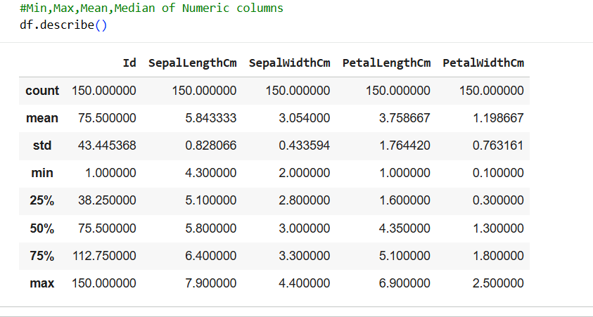
Median:
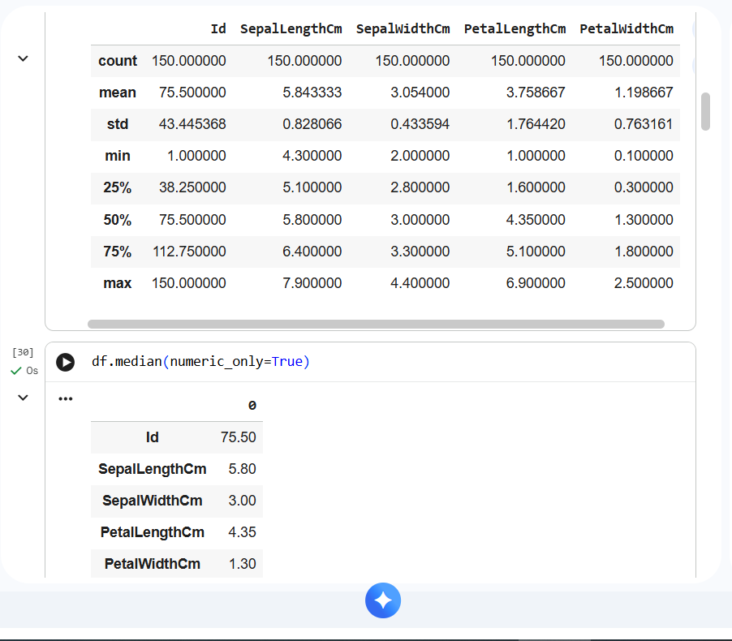

#QUESTION NO:3
Histogram and Boxplot: 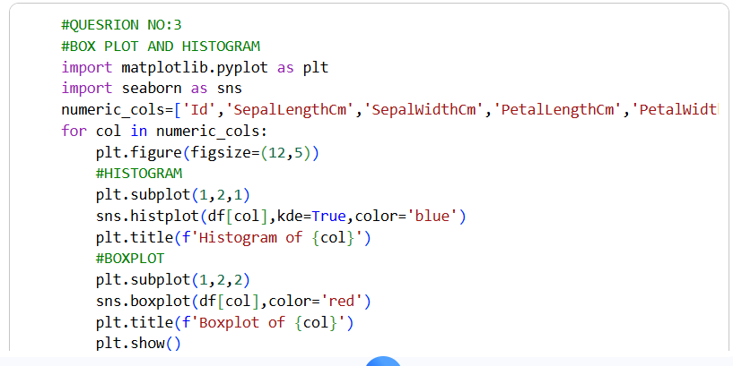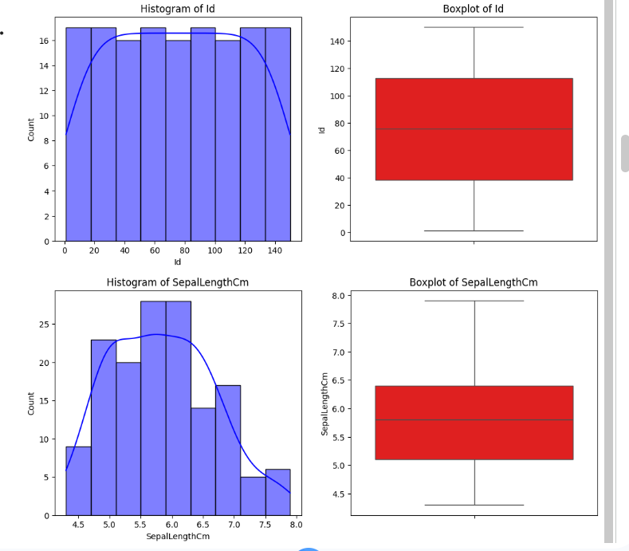
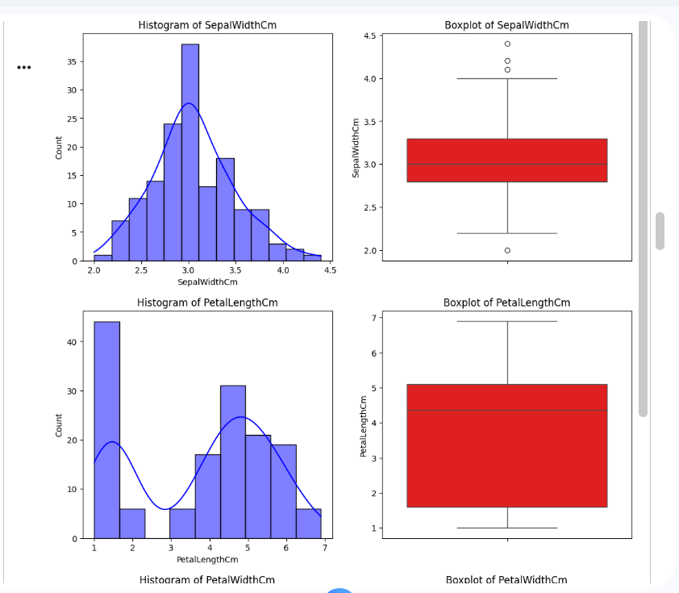
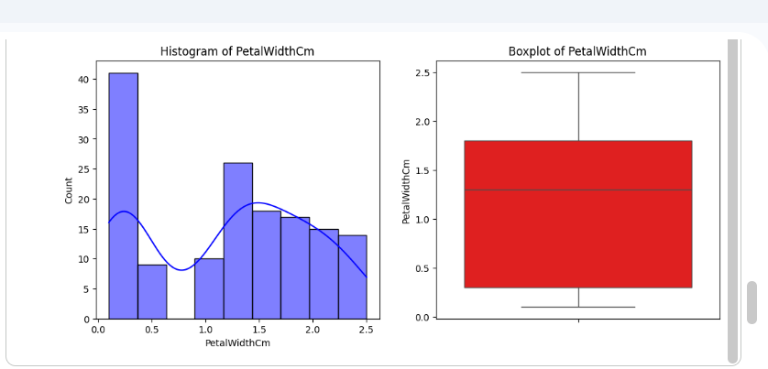

- ID:
- Spread:
Range is wide(1 to 150),values evenly spread because it is just a serial index.
IQR is not meaningful for analysis.
- Outliers:
Boxplot shows a few outliers on both lower and upper ends.
- Shape:
Histogram is left-skewed(tail toward left side).
Peak around 3.0 cm(most common width).

- SepalLengthCm:
- Spread:
- Value roughly between 4.3 and 7.9 cm.
- IQR shows most values lie between about 5.1 to 6.4 cm.
- Outliers:
- Boxplot show no outliers.
- Shape:
- Histogram appears slightly right-skewed(tail on the right).
- Distribution is almost close to normal but slightly stretched toward higher values.

- SepalWidthCm:

- Spread:
- Values between 2.0 and 4.4 cm.
- IQR shows most values between 2.8 and 3.3 cm.
- Outliers:
- Boxplot shows a few outliers on both lower and upper ends.
- Shape:
- Histogram is left-skewed
- Peak around 3.0 cm(most common width).

- PetalLengthCm:

- Spread:
- Values range from 1.0 to 6.9 cm.
- Very wide spread because species differ a lot.
- IQR shows majority between 3.5 and 5.1 cm.
- Outliers:
- A few outliers seen around 3 cm and below.
- Shape:
- Histogram is strongly right-skewed.
- Two visible peaks(bimodal/multimodal) because Setosa and other differ sharply.
- PetalWidthCm:

- Spread:
- Values range from 0.1 to 2.5 cm.
- IQR roughly between 1.0 to 1.8 cm.
- Outliers:
- Boxplot shows one or two very small outliers on lower end.
- Shape:
- Histogram is right-skewed.
- Clear separation between Setosa vs other species causes two clusters.

#QUESTION NO: 4
- Numeric vs Numeric
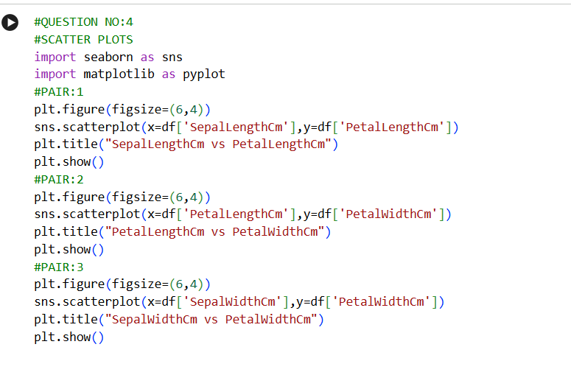
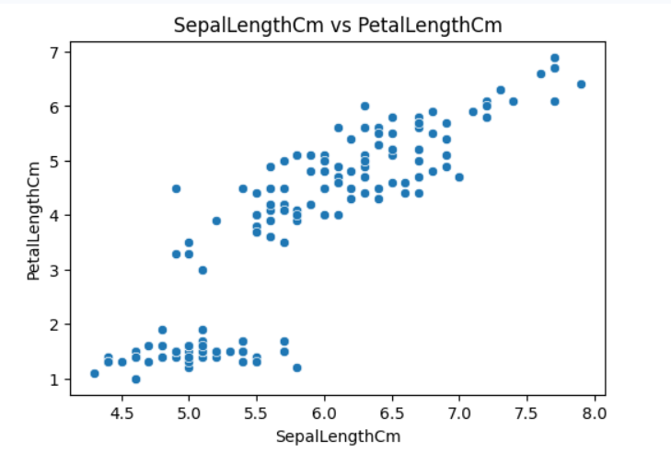
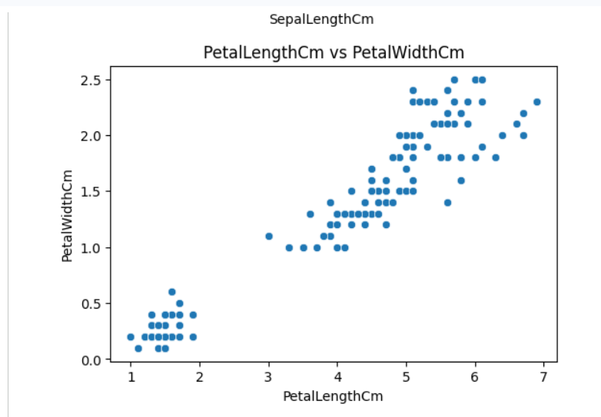
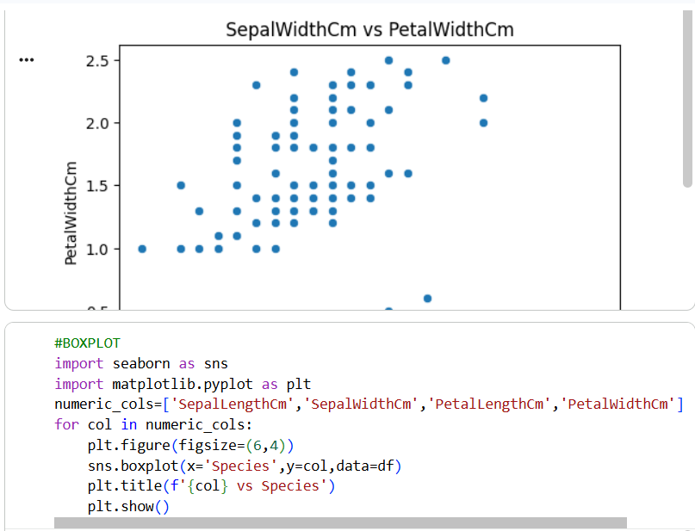

#Do you see any trend or pattern?
YES,
Strong positive trend in both Sepal Length Cm vs Petal Length CmPetal Length Cm vs Petal Width Cm .
Very weak trend in Sepal Width Cm vs Petal Width Cm.

#Which pair seems strongly related?
Petal Length Cm vs Petal Width Cm
This pair shows the strongest relationship because the scatterplot forms a clean upward pattern and points are tightly grouped.

Numeric vs Categorical:
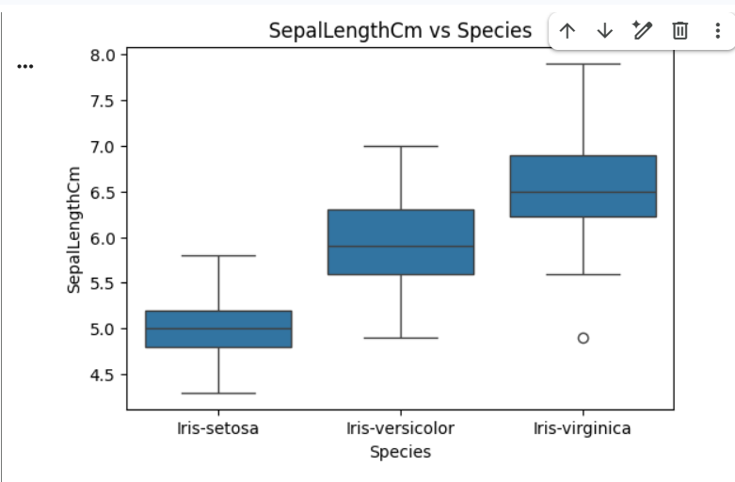
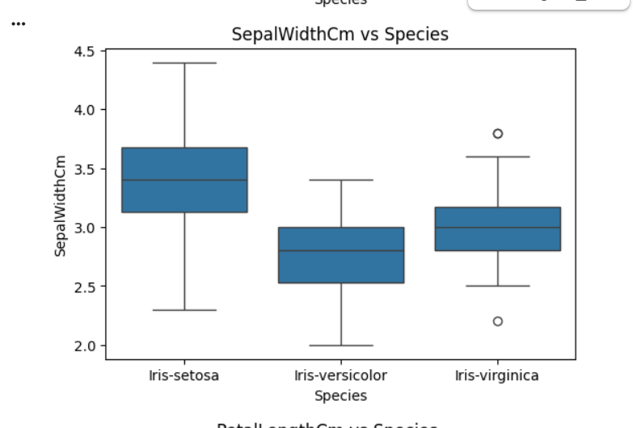
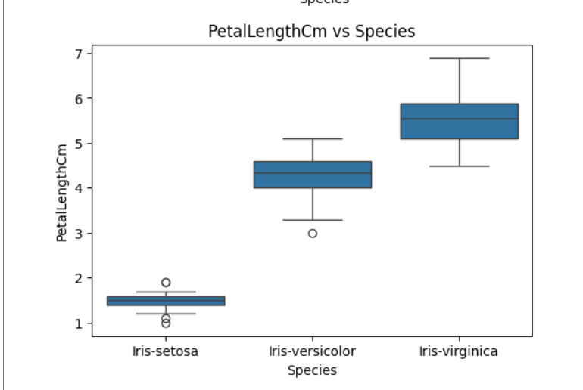

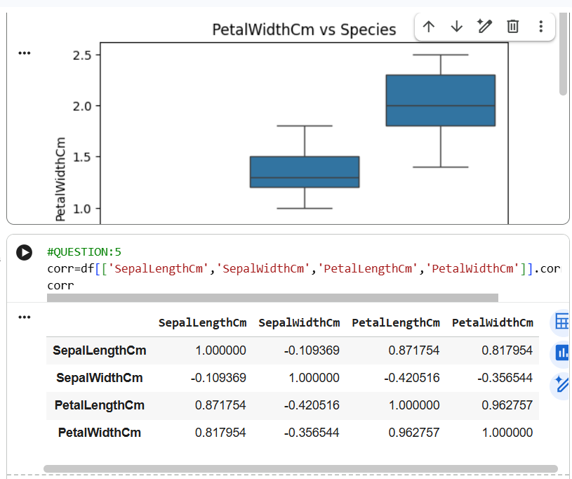

#Does Species seem to affect petal length or petal width?
YES, species clearly affects both petal length and petal width.
Iris-setosa has very small petals,
Iris-versicolor has medium-sized petals,
Iris-virginica has the largest petals.

#Do all species have similar sepal and petal sizes?
No, all species do not have similar sepal and petal sizes.
Sepal and petal measurements vary for each species.
Setosa has the smallest petal size and highest sepal width.
Versicolor is in the middle.
Virginica has the largest sepal length and petal size.

#QUESTION NO:5

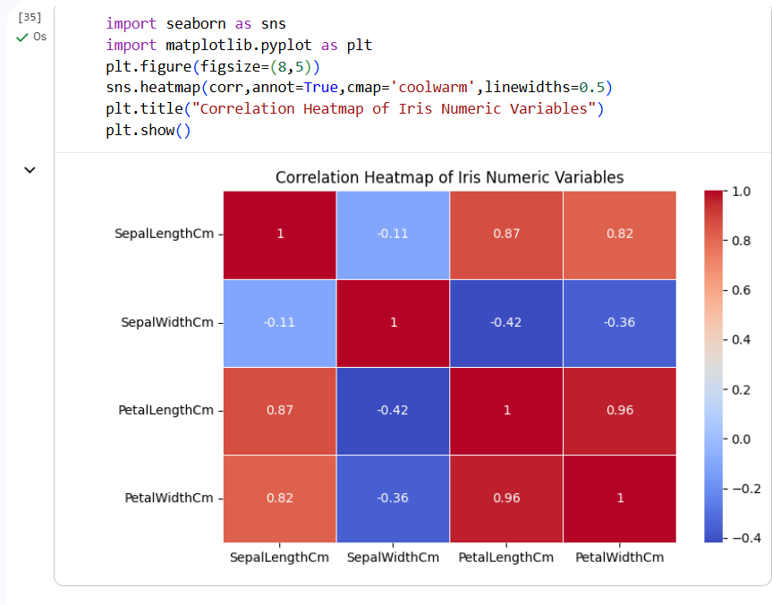
#Which two variables have the highest positive correlation?
Petal Length Cm and Petal Width Cm have the highest positive correlation(0.96).
This means that as petal length increase petal width also increase almost perfectly.

#Are any variables weakly correlated (correlation near 0)?
YES , Sepal Width Cm is weakly correlated with all other variables:
SepalWidthCm vs SepalLengthCm=-0.11
SepalWidthCm vs PetalLengthCm=-0.42
SepalWidthCm vs PetalWidthCm=-0.36
These values show very weak or weak negative relationships.

#Based on correlation, which variables look most useful to predict others?
PetalLengthCm is the most useful predictor because it has strong correlation with PetalWidth(0.96) and SepalLength(0.87).
SepalLengthCm is also a useful predictor since it has strong positive correlation with PetalLength and Petal Width.
SepalWidthCm is not useful for prediction due to its weak correlaations with all variables.

#QUESTION NO:6
Independent vs Dependent
- If we want to predict species which variable are independent and which are dependent?Why?
Dependent variable:
Species:
We are trying to predict the species so it become the target /output variable.
Independent variable:
SepalLengthCm
SepalWidthCm
PetalLengthCm
PetalWidthCm
These features describe the flow and help us to predict the species.
Reason:
Because Species depends on the measurements of sepal and petal features but those measurements do not depends on the Species label itself.

2.If we build a regression model to predict PetalLengthCm which variables would you choose as predictor?Why?
Best independent variables(predictor):
PetalWidthCm(very strong correlation=0.96)
SepalLengthCm(strong correlation=0.87)
Non good predictors:
SepalWidthCm(weak correlation=-0.42)
Reason:
Regression works best when predictors have strong linear relationships with the target.
Since petalwidth and sepalLength are highly correlated with petalLength they provide the best predictive power.
3.Give one example of two variables that are clearly NOT independent of each other. Explain using plot or correlation.
Example:
PetalLengthCm and PetalWidthCm
Reason:
Correlation=0.96 almost perfect.
Scatterplot shows a strong upward linear pattern.
These two variables change together so they are not independent.

4.Give one example where variables appears closer to independent(weak relationship).
Example:
SepalWidthCm and SepalLengthCm
Reason:
Correlation=-0.11(very weak)
Scatterplot shows no clear trend or pattern.
This means they behave mostly independently.

